Algorithms Project Pipeline

Analysis:

* Merge sort isolates regions of an array.
* Once it has isolated 1 element, it calls upon a merging function to attach it to the second isolated region i.e. **expanding our restricted region** within the array.
* Merge functions with the expectation that the array it receives is sorted on each half, respectively.
* Insertion sort is an entirely different system altogether. A hybrid between the two may have different interpretations.

MS assumes array is sorted when (p is no longer less than q).

Once that condition is broken, a series of merging calls occur.

MS should assume an array is sorted when (IS has been called).

The easiest way to do this is:

We should have MS assume an array is sorted when it is less than a certain size, i.e. the size which will be sorted by our IS.

Ex:

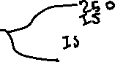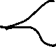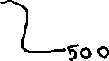

In this example, if S greater than 250, it will be handled by MS. If equal or less, it will be handled by IS.

So, if S=250, we should have 3 MS calls (excluding initial) and 4 IS calls.

To check my work, I inputted a couple of print statements within MS and IS:

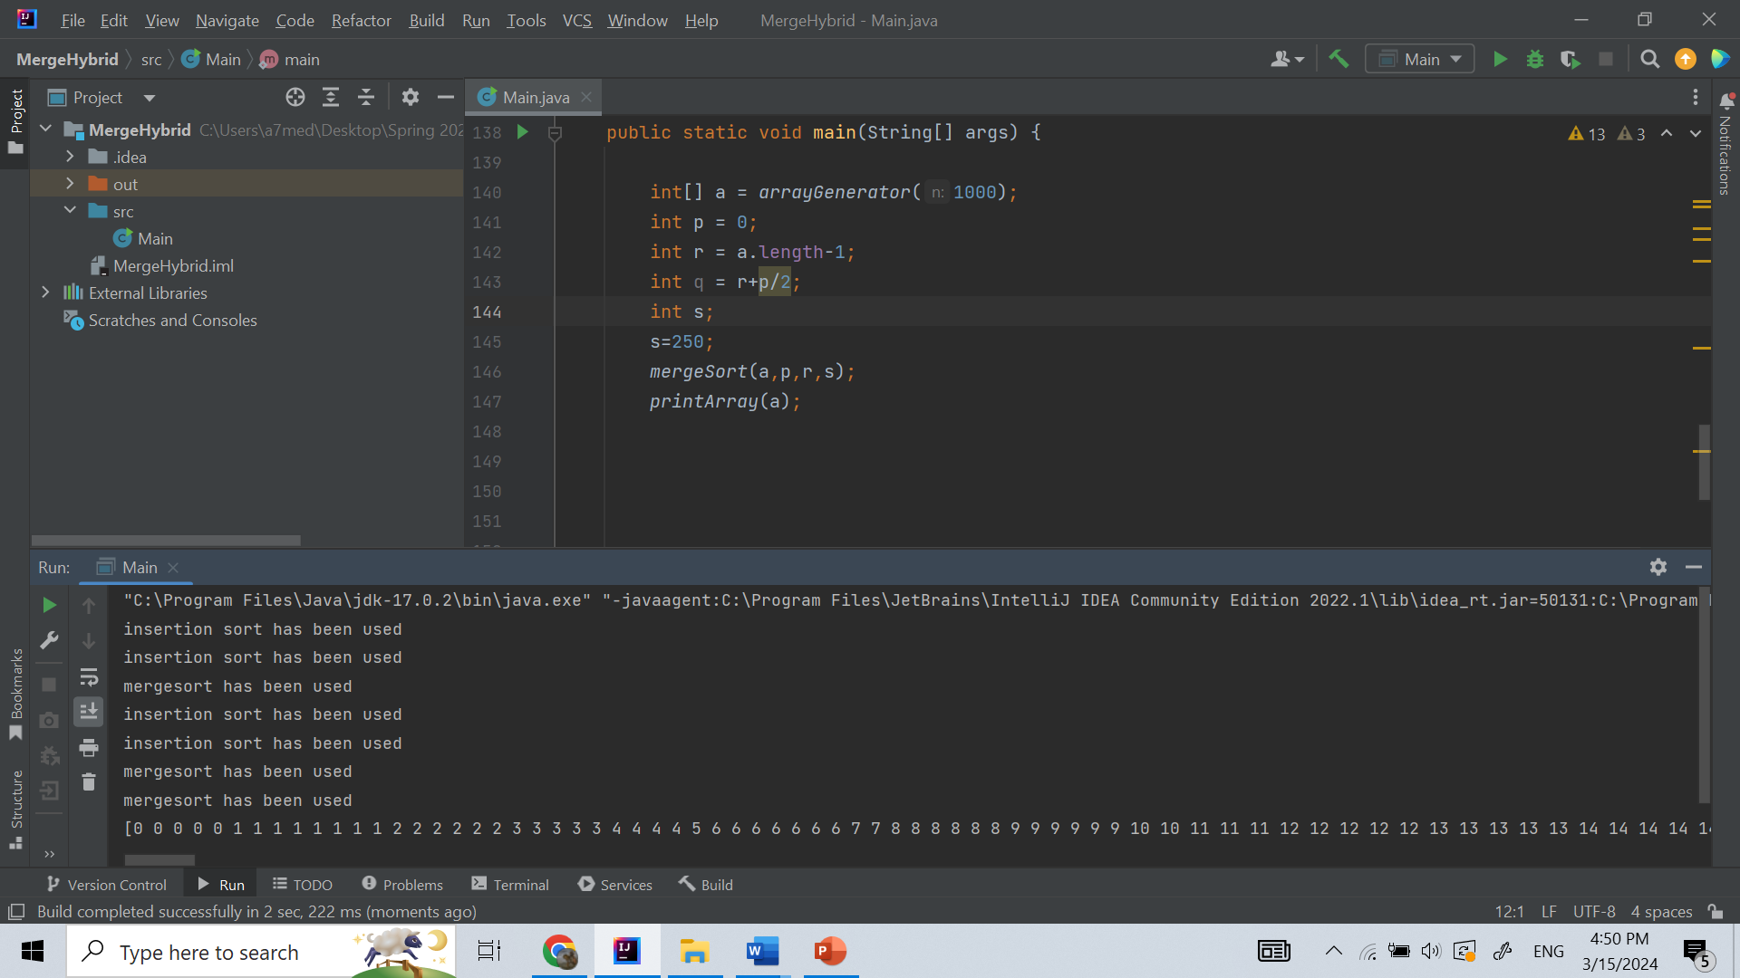

Additionally, I printed the resultant array at the end. Based on these results, I believe the MS hybrid functions as intended.

To plot data points, I inserted my function calls into a loop and incremented S by 300 each time. At some values, the time it takes increases substantially, and will start taking hours for each iteration as we approach n. Due to this fact, I chose to limit my S values to the seconds to minutes region (S values within thousands, not tens of thousands).

**Time is formatted in ISO 8601**:

The Time for S = 1 is:

PT32.1552553S

The Time for S = 2001 is:

PT54.8362532S

The Time for S = 4001 is:

PT1M31.0013762S

The Time for S = 6001 is:

PT1M30.1716608S

The Time for S = 8001 is:

PT3M18.048318S

The Time for S = 10001 is:

PT3M18.0520517S

The Time for S = 12001 is:

PT3M17.9968546S

The Time for S = 14001 is:

PT5M49.9599451S

The Time for S = 16001 is:

PT5M45.6647141S

The Time for S = 18001 is:

PT5M34.2954022S

The Time for S = 20001 is:

PT5M39.0184936S

The Time for S = 22001 is:

PT5M3.6554531S

The Time for S = 24001 is:

PT5M2.1429015S

The Time for S = 26001 is:

PT10M36.0436917S

The Time for S = 28001 is:

PT10M17.2708321S

The Time for S = 30001 is:

PT10M16.4533853S

The Time for S = 32001 is:

PT10M16.7888382S

The Time for S = 34001 is:

PT10M19.1862849S

The Time for S = 36001 is:

PT10M16.6904303S

The Time for S = 38001 is:

PT10M16.7529899S

The Time for S = 40001 is:

PT10M16.7564961S

The Time for S = 42001 is:

PT10M16.9970914S

The Time for S = 44001 is:

PT10M16.9981599S

The Time for S = 46001 is:

PT10M20.4636715S